|  |
| --- |
|  |
|  |

PowerPoint uses the programming language VBA (Visual Basic for Applications). This is similar to VB.NET, which you may have used before.

**Appendix 4 - PowerPoint Programming**

A4

The Interactive

Kiosk Project



***Aim:*** *To look at programming in PowerPoint.*

***Note:*** *This project does not need to use programming and the tasks below don’t teach you how to program. However, if someone in your group already has programming skills then it’s not difficult to use these in PowerPoint. These tasks will show you how to access the programming tools.*

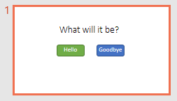

#### Task 1 – Changing Text in a Text Box

We’ll start by using buttons to change the text in the title box.

1. Create up a new presentation with a title and two buttons.
2. Save the file as a *Macro-Enabled Presentation* so that you can run the programs you create. Macros are really just subroutines.

*Mac users might need to allow Macros in ‘Preferences / Sharing and Privacy / Security’.*

1. 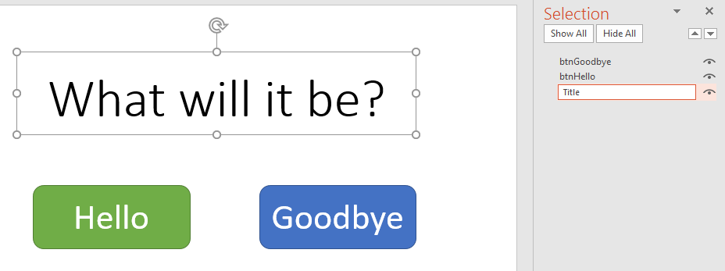You’ll need to name the title box so that you can refer to it in your programming code. Select it and click ‘Format / Selection Pane’. In the pane that opens on the right, change the name to ‘Title’. You can change the names of the buttons as well if you like, but we won’t be using these names in this code.

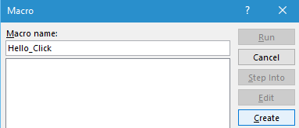

1. Select ‘View / Macros’ and type the Macro name “Hello_Click”. Click ‘Create’. The VB editor (actually an IDE) will open up.
2. Type the ‘Hello_Click’ subroutine as below. Whilst you are there, copy and paste this and create the ‘Goodbye_Click’ subroutine as shown. Save the file.

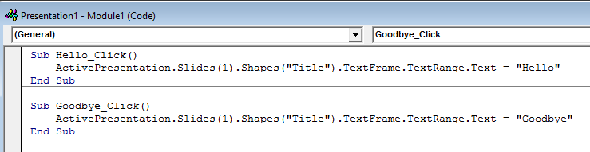

|  |
| --- |
| **PowerPoint Programming (page 2)** |

1. 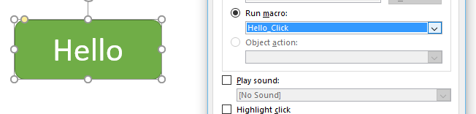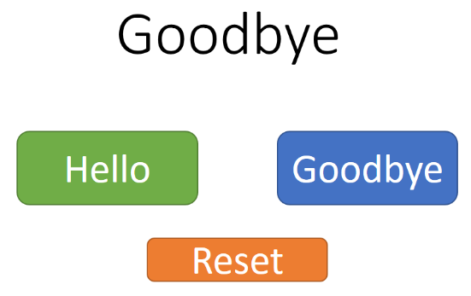We will now assign these two macros to the two buttons we have created. Return to your presentation (using the tabs at the base of the screen in Windows) and select your *Hello* button. Click ‘Insert / Action’ and select ‘Hello_Click’ from the ‘Run macro’ drop-down menu. Click ‘OK’.
2. Repeat this, assigning the ‘Goodbye_Click’ subroutine to the second button.
3. View your presentation and check that the buttons both change the text in the text box as expected.
4. Notice that when you exit your presentation, the values in the text boxes stay as you left them. Add a *Reset* button and macro which change the title back to the original text.

#### Task 2 – Macro Security

If you close and reopen your presentation, you may see a security warning along the top of the screen. This will more than likely be the case if you have moved your file or stored it online. You will need to enable macros before they can be put to use.



Other security settings are available if you click ‘Developer / Macro Security’, although these will probably not be required.

#### Task 3 – Example Interface

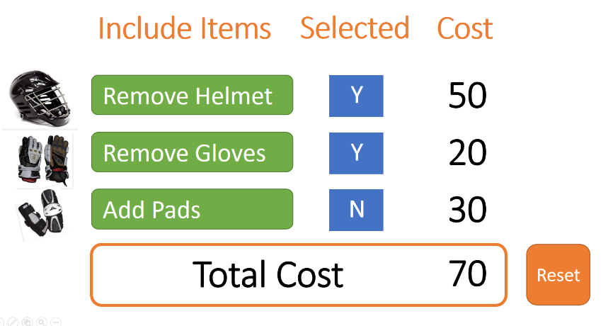An example interface with calculations and changing text is shown on the right.

One of the four subroutines in use is shown on the following page. Two of the others can be created in seconds by copying this sub into a text editor and changing all the instances of ‘Helmet’ to ‘Gloves’ etc.

Remember that if you move the slide’s position in the presentation, all the references will change (ours is Slide 2). There are better ways of setting this up.

Creating this screen in PowerPoint would be a great learning task.

|  |
| --- |
| **PowerPoint Programming (page 3)** |

#### Task 4 – The Developer Options in PowerPoint (PC Version Only)

To access further programming functions, enable the *Developer* tab on the ribbon.

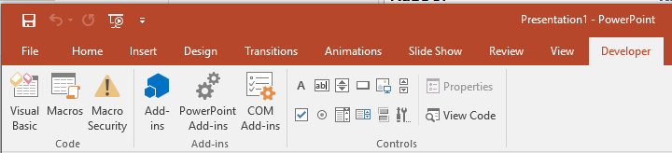

To open the Develop tab, select ‘File / Options / Customize Ribbon’ then tick the ‘Developer’ box on the right-hand side. If using a school computer, you may be asked by your teacher to hide this tab again when you are finished.

